**FLUIDIC MICROSYSTEM DESIGN WITH ACRYLIC.**

***Version 1.0***

**Produced by: Héctor Oliva, Sebastián Reyes & Diana Sotelo**

# OBJECTIVE

To demonstrate to the Uniandes community the procedure that must be followed to fabricate a microfluidic system using transparent acrylic in the CMUA laboratory of the Electrical and Electronic Engineering Department.

# SCOPE

To inform the Uniandes community about the process of manufacturing microchannels in acrylic, using methyl methacrylate (dichloromethane) as an adhesive.

# DESIGN SPECIFICATIONS AND RESTRICTIONS

### Format

To properly implement the previous design, a 2 mm thick acrylic plate was obtained. Subsequently, the design in AutoCAD (or Corel Draw) in .pdf format was sent to a laser cutting machine to obtain the previous design in acrylic plates.



Figure 1: AutoCAD design of the system.

MDF is used for the support base of the system (12 x 7 cm), and 3mm holes are made using laser cutting to place 2-inch nails for the guide.



Figure 2: Example of base for assembly.

### Tools

To carry out this work, a silicone gun, a 1mL syringe, a 3mL syringe, an acetate sheet, and dichloromethane are required.

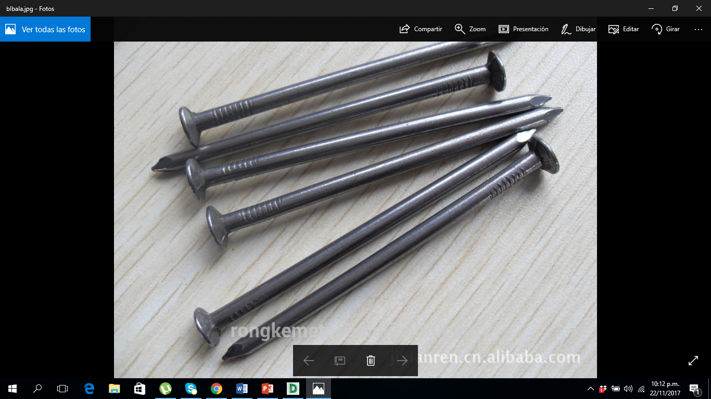

Figure 3: Example of nails used in assembly.

***Note:*** The final design is the superposition of the 3 layers of acrylic manufactured with laser cutting. The design must contemplate the original dimensions of the design whose format is in .dxf.

# STEP BY STEP OF THE FABRICATION SUPPORT.

1. The assembly must be properly assembled before gluing the three acrylic parts. To do this, the nails (2 inches) must be inserted into the 3 mm holes in the MDF.
2. Once the nails or pins are fixed to the MDF, the objects are permanently fixed with a silicone gun, ensuring that the heads of the nails and MDF are correctly joined once the silicone cools.



Figure 4: MDF with two-inch nails.



Figure 5: Nails and DM board permanently fixed.

# STEP BY STEP OF THE ACRYLIC SYSTEM.

1. One of the end sheets (sheet 2) is positioned on the support and the center sheet (sheet 1) is positioned at a height of approximately 5 cm (the necessary height to have enough space to approach the needle of the 1 mL syringe).



Figure 6: Lower and upper sheet positioned on the support.

1. Within a period of between 30 seconds and 1 minute, dichloromethane (methyl methacrylate) should be added, using the 1 mL syringe, uniformly onto the lower sheet. When the application of the adhesive is finished, the upper sheet must be released onto the lower sheet, so that they are aligned and fixed on top of each other. The adhesive must be allowed to dry for at least one minute.



Figure 7: Application of methyl methacrylate.

1. An acetate sheet (or the needle of the syringe) is used to remove excess adhesive in the channels of the system.

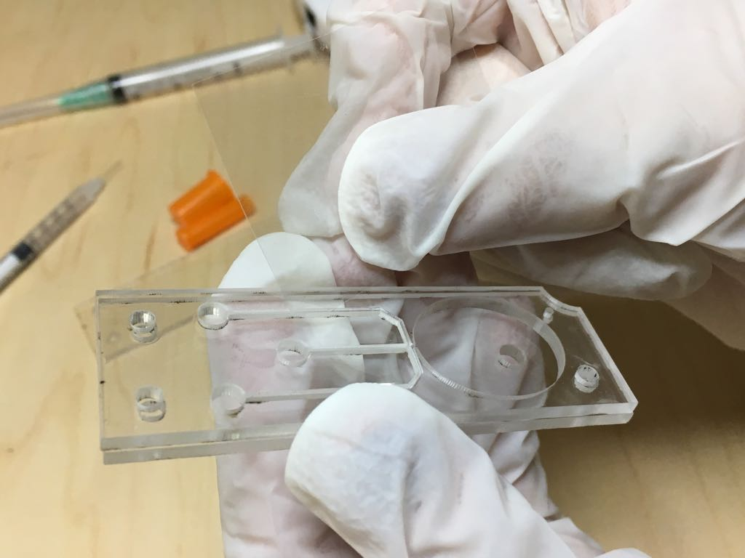

Figure 8: Use of acetate to remove excess methyl methacrylate.

1. The first two steps are repeated, this time taking the union of the two previous sheets (sheets 1 and 2) as the lower one and the remaining sheet as the upper one (sheet 3). The adhesive must be allowed to dry for at least one minute.



Figure 9: Repeat the first two steps.

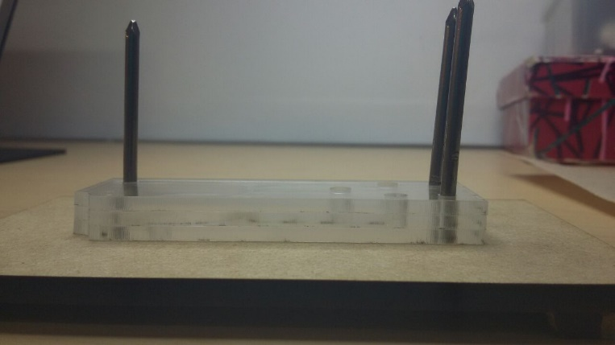

Figure 10: Laminates 1, 2, and 3 aligned and fixed together.

1. The system is checked for leaks (if any) by testing it with a fluid. Colored water is recommended for ease of recognition. After identifying any leaks, the system is filled with a little bit of methacrylate (taking care not to overfill, as it can also obstruct the channels).

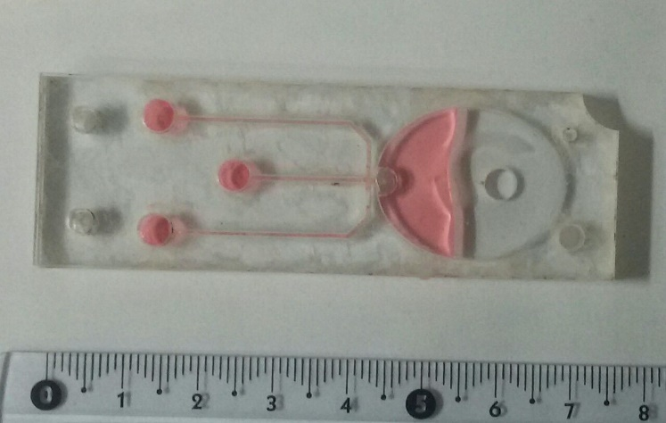

Figure 11: Identification of leaks in the system.

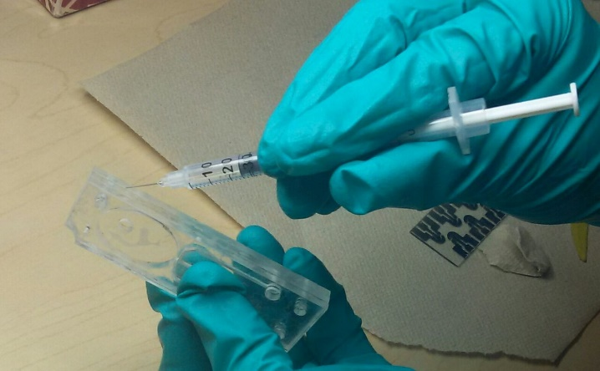

Figure 12: Sealing of leaks in the system.

1. Using the acetate sheet, remove the excess methylene chloride.

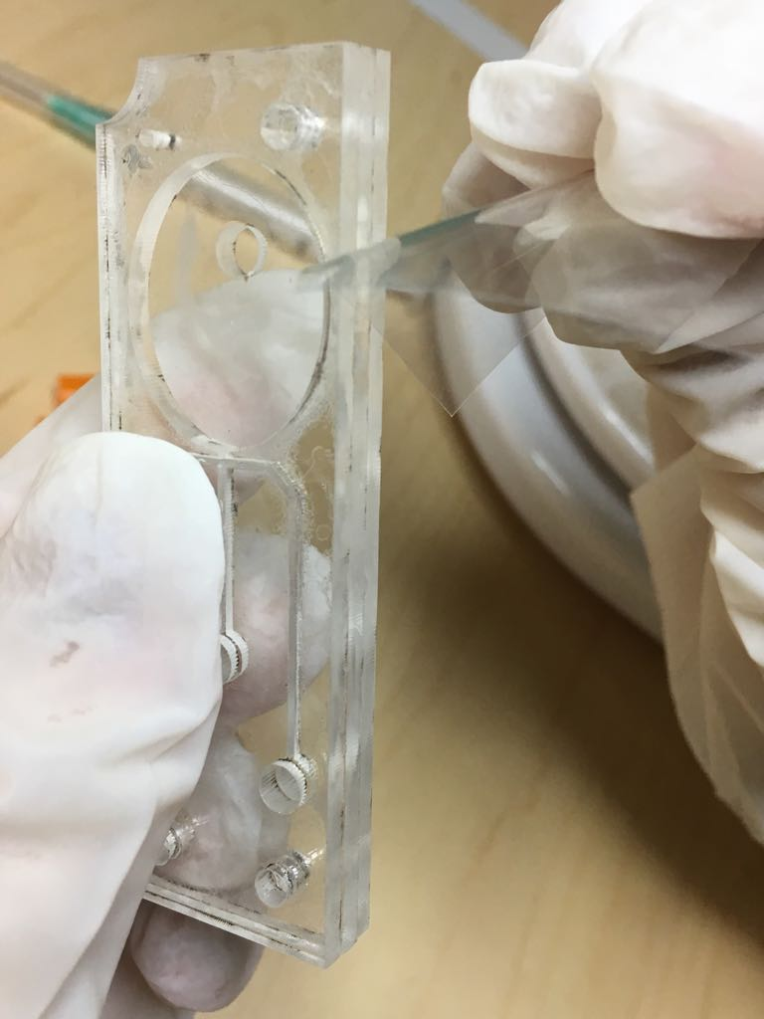

Figure 13: Removal of excess methylene chloride.